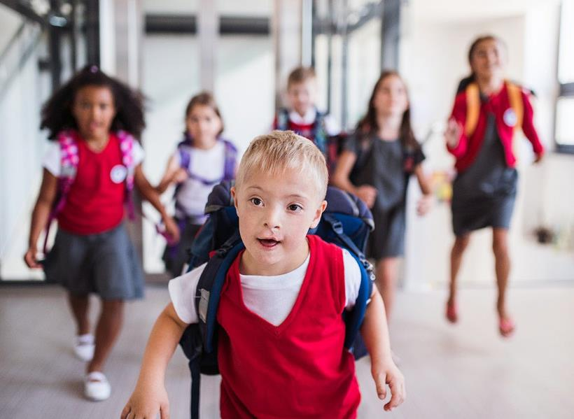

I AM GOING BACK TO SCHOOL

I am going back to school soon.

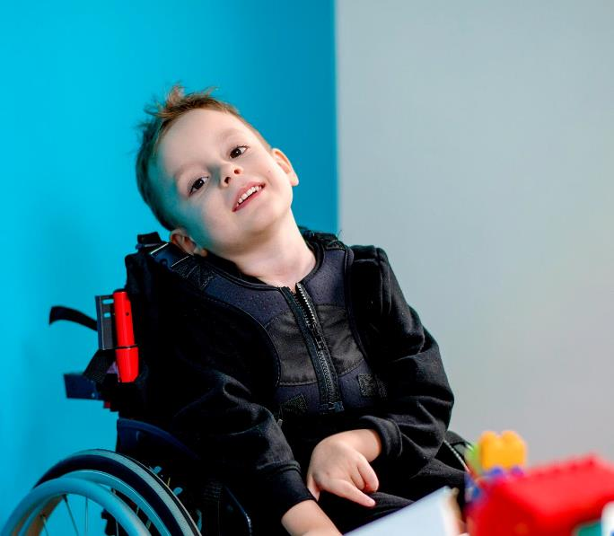

I have not been at school for a while.

I may feel excited and a little bit nervous. If I feel nervous, I can talk to my family.
They can help me.

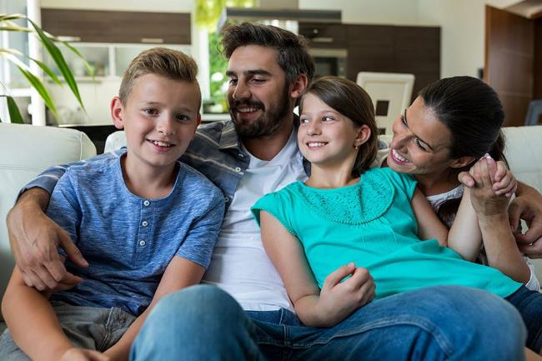
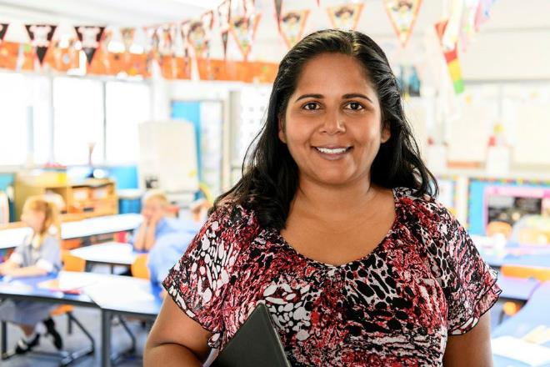

I can talk to my teachers. They can help me.

When I go back to school I will see some of my teachers and friends.

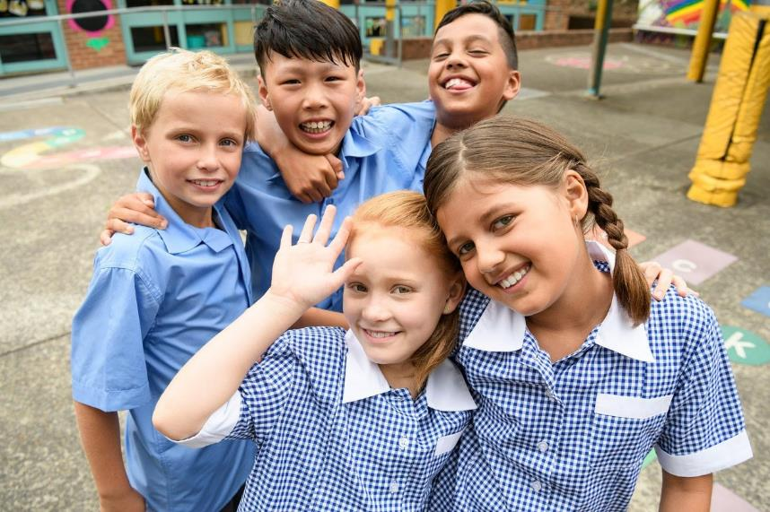

School will be different and that is ok.

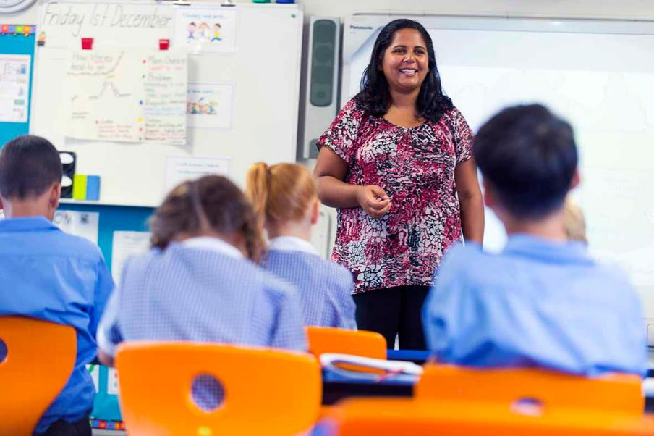

It will be good to see some of my teachers and friends.

Sometimes my teachers will wear masks. The masks cover their mouths and noses but I can still see their eyes.
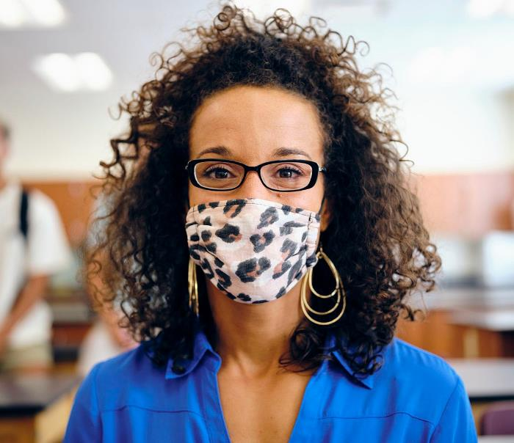
They wear masks to help keep everyone at school healthy and safe.

Students in Grade 3 and above will wear masks indoors.

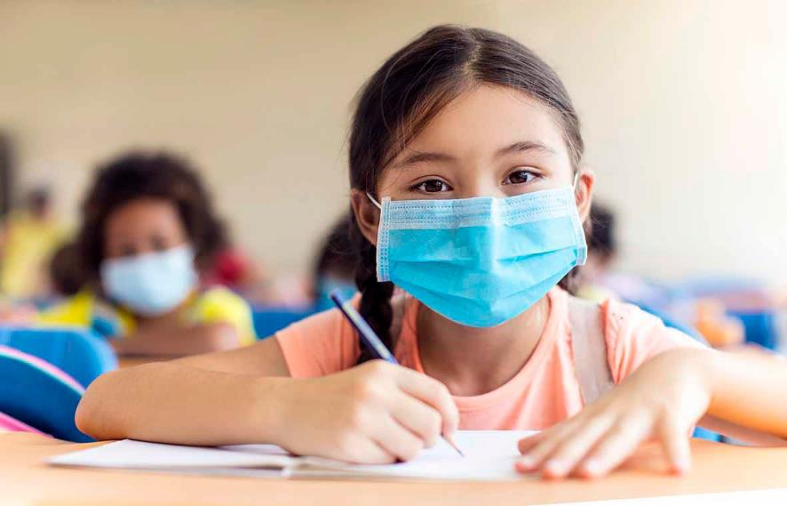

I will wear a mask when I am inside OR I don’t have to wear a mask and this is OK.

Sometimes my teacher or some of my friends might not be at school. This is OK.

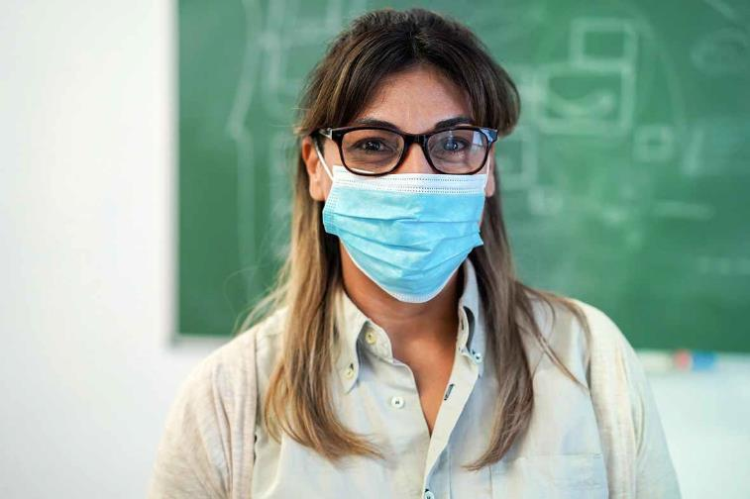

If my teacher is away I will have a different teacher. They will help me with my learning. If I am worried I can talk to the teacher. They can help me.

My classroom may look different.

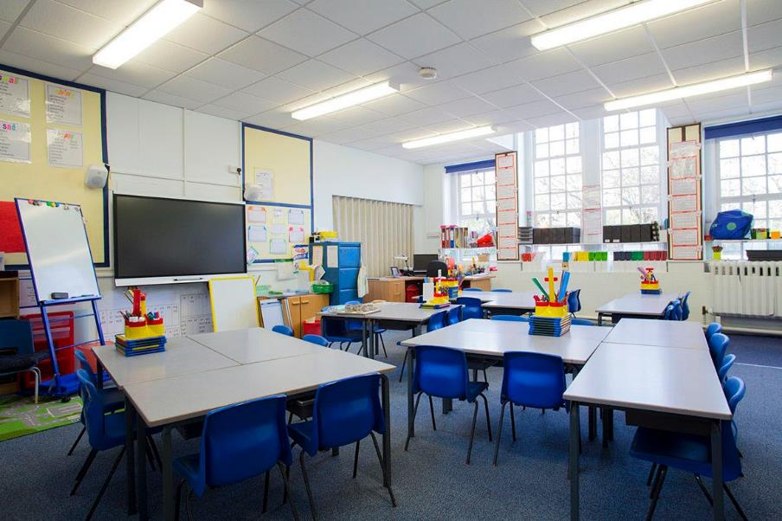

I may sit at a different desk. This is ok.

I will wash and sanitise my hands to help keep everyone at school healthy and safe.

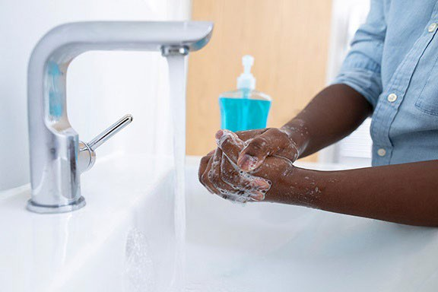
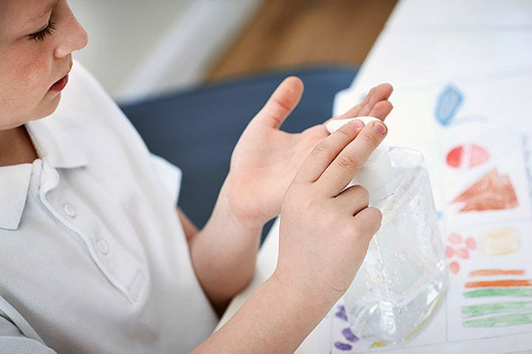

My school is a good place for me to do my learning.

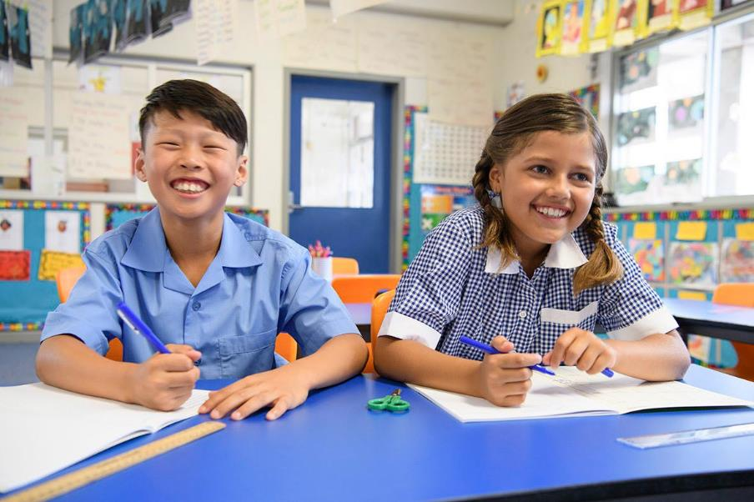

It is ok to go back to school.

Notes for families
This story is a starting point for supporting your child with going back to school. You may want to talk to your child about:
- Wearing their school uniform
- What day they go back – you could mark it on the calendar
- How they will get to school
- What they will have for lunch
- If they will be wearing a mask
- What PPE support staff will wear when providing personal care
You could also use your own photos and change the text to suit your child and family. RAT tests are not included in this story because they happen at home and are optional.

