I AM GOING BACK TO SCHOOL
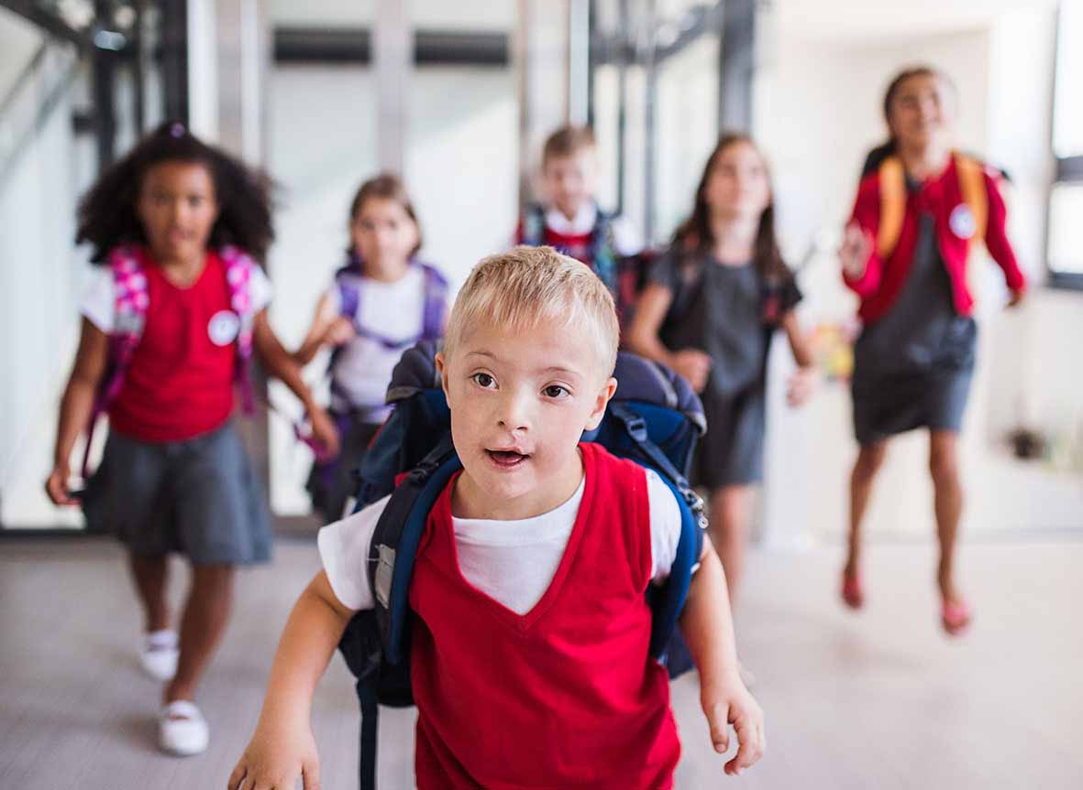

I am going back to school soon.
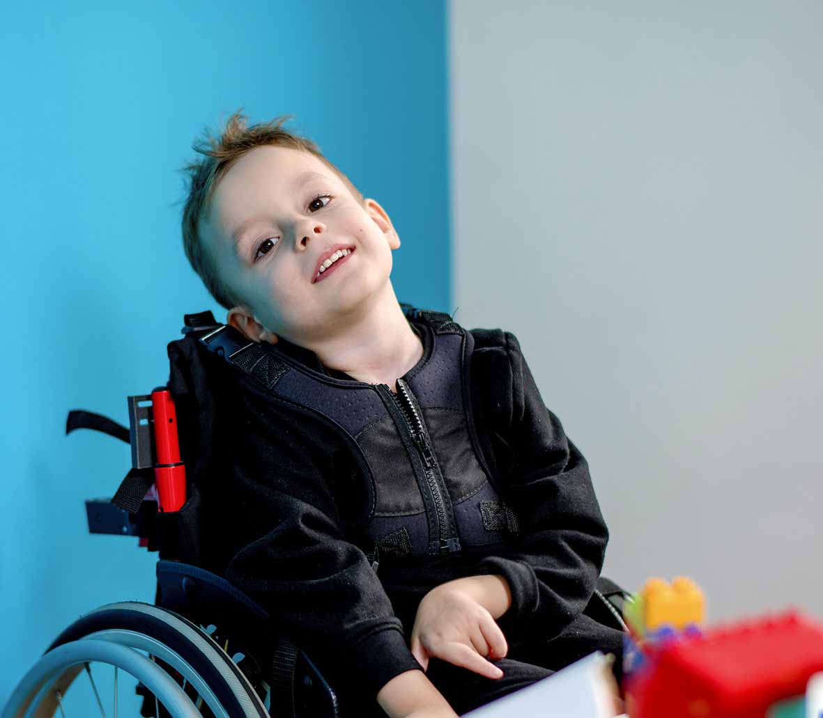

I have not been at school for a while.

I may feel excited and a little bit nervous. If I feel nervous, I can talk to my family.
They can help me.
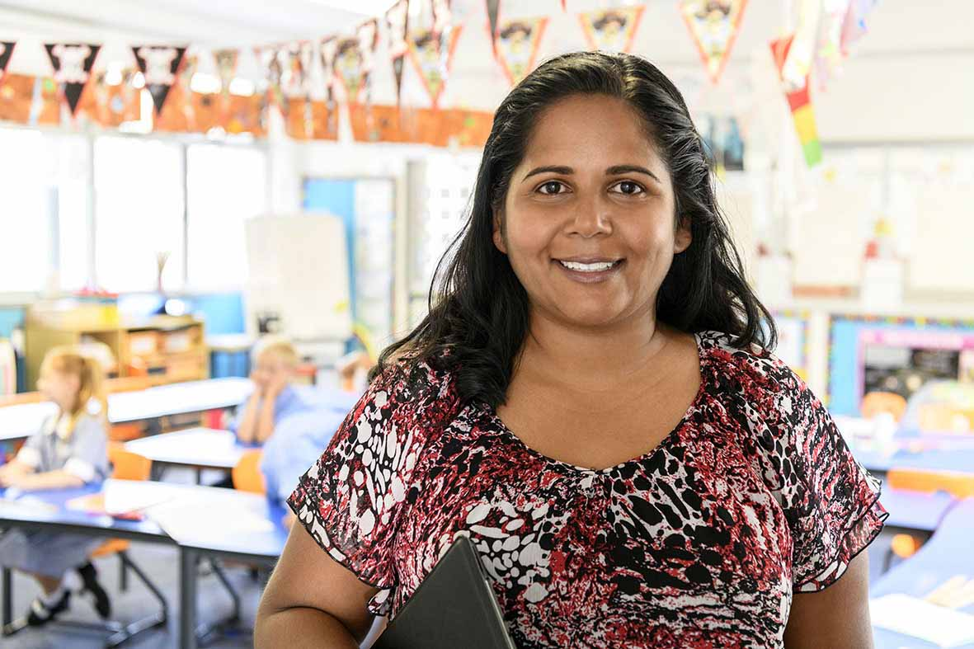
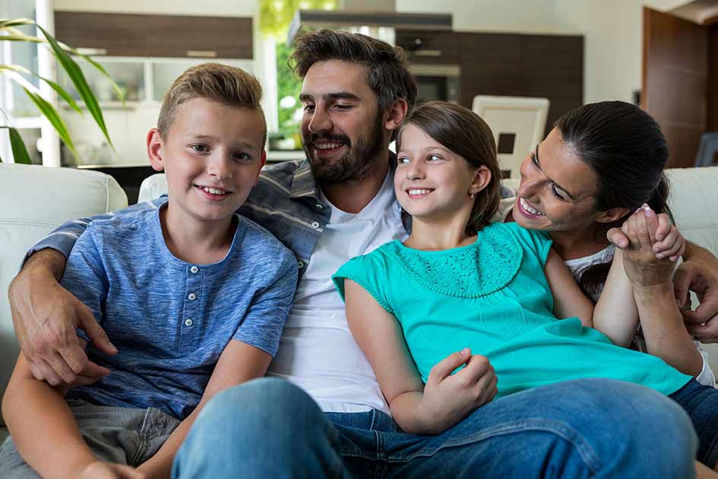

I can talk to my teachers. They can help me.

When I go back to school, I will see some of my teachers and friends.

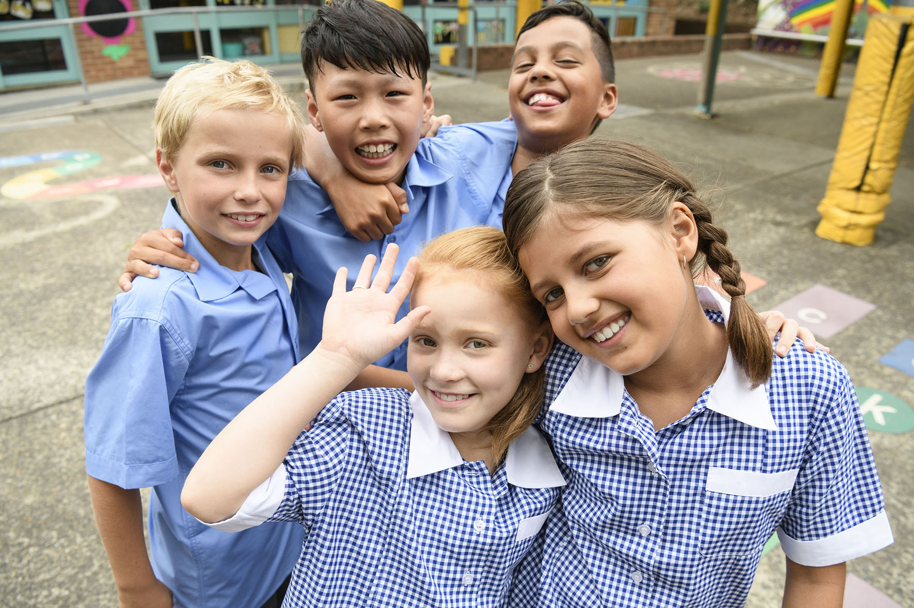

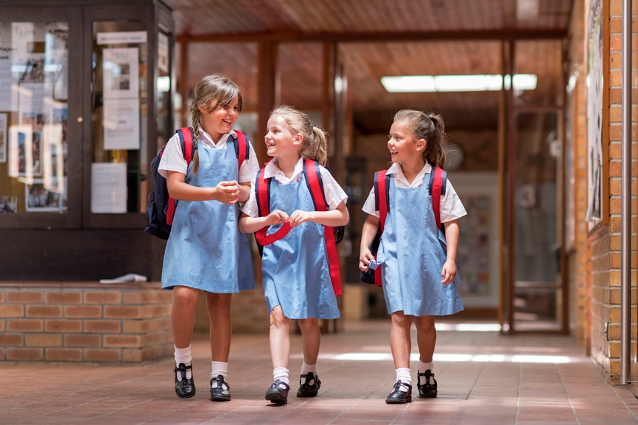
My parents may not be able to take me into my classroom but that is ok.

I can get to class by myself or with my teacher.

School will be different and that is ok.
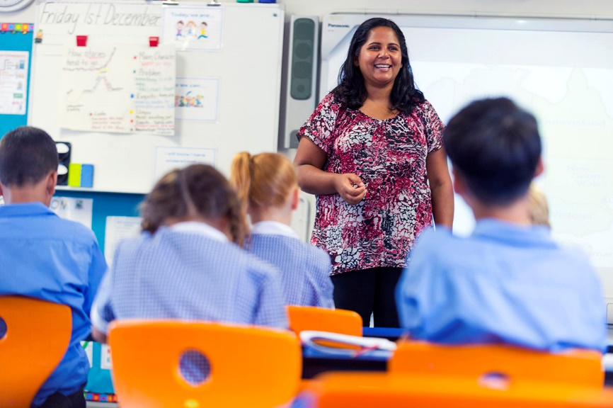

It will be good to see some of my teachers
and friends.

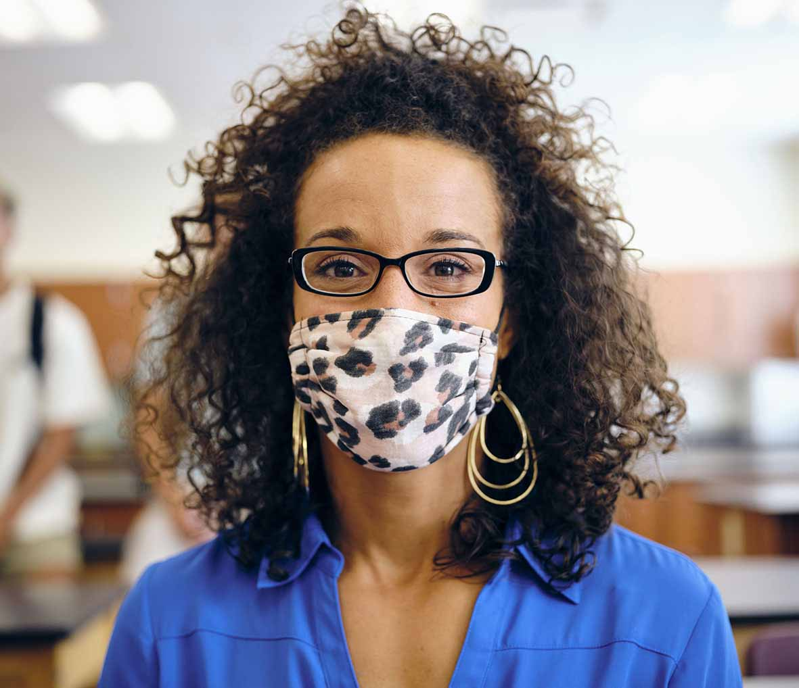
Sometimes my teachers will wear masks. The masks cover their mouths and noses, but I can still see their eyes.
They wear masks to help keep everyone at school healthy and safe.

My classroom may look different.
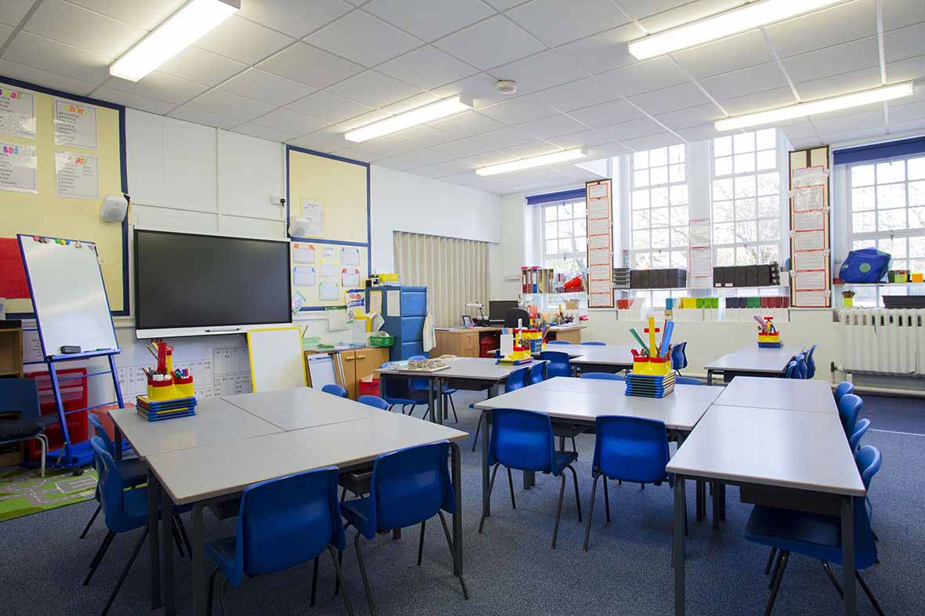

I may sit at a different desk. This is ok.

I will wash and sanitise my hands to help keep everyone at school healthy and safe.

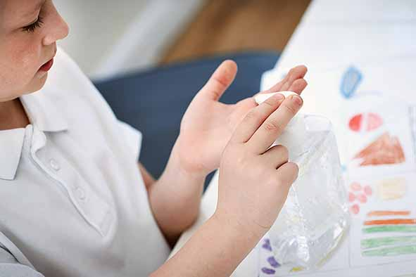
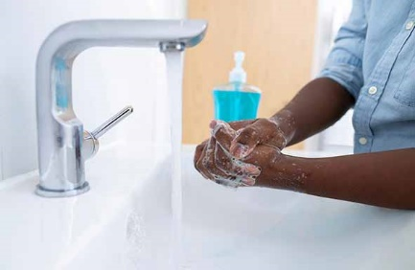

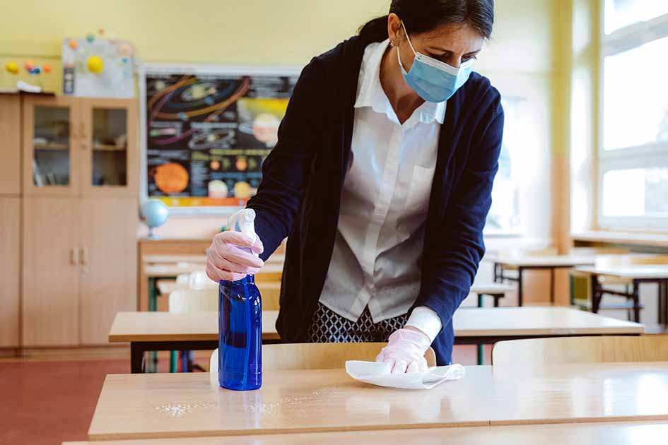
At school, people are doing a lot of extra cleaning. This is ok.

They are doing this to help keep us healthy and safe.

My school is a good place for me to do my learning.
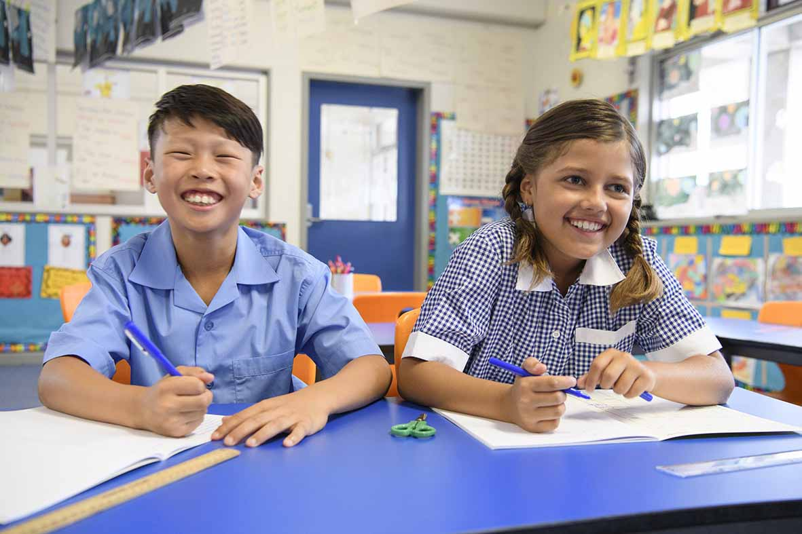

It is ok to go back to school.

Notes for families

This story is a starting point for supporting your child with going back to school. You may want to talk to your child about:
- Wearing their school uniform
- What day they go back – you could mark it on the calendar
- How they will get to school
- What they will have for lunch
- If they will be wearing a mask
- What PPE support staff will wear when providing personal care
You could also use your own photos and change the text to suit your child and family.

